1. **Context model**

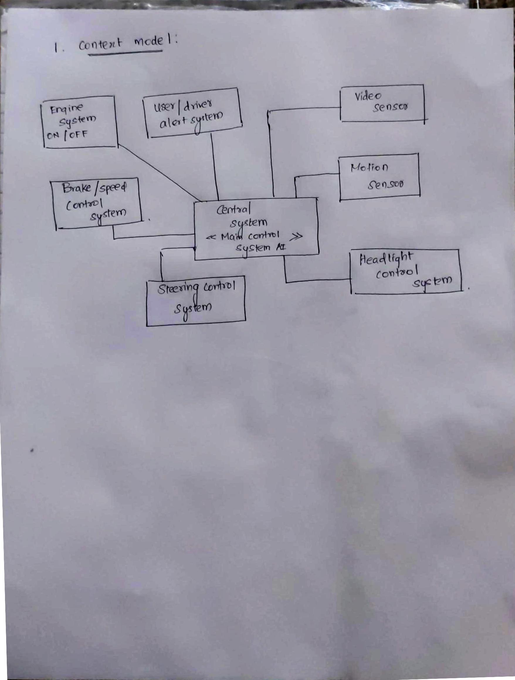

1. **State diagram**

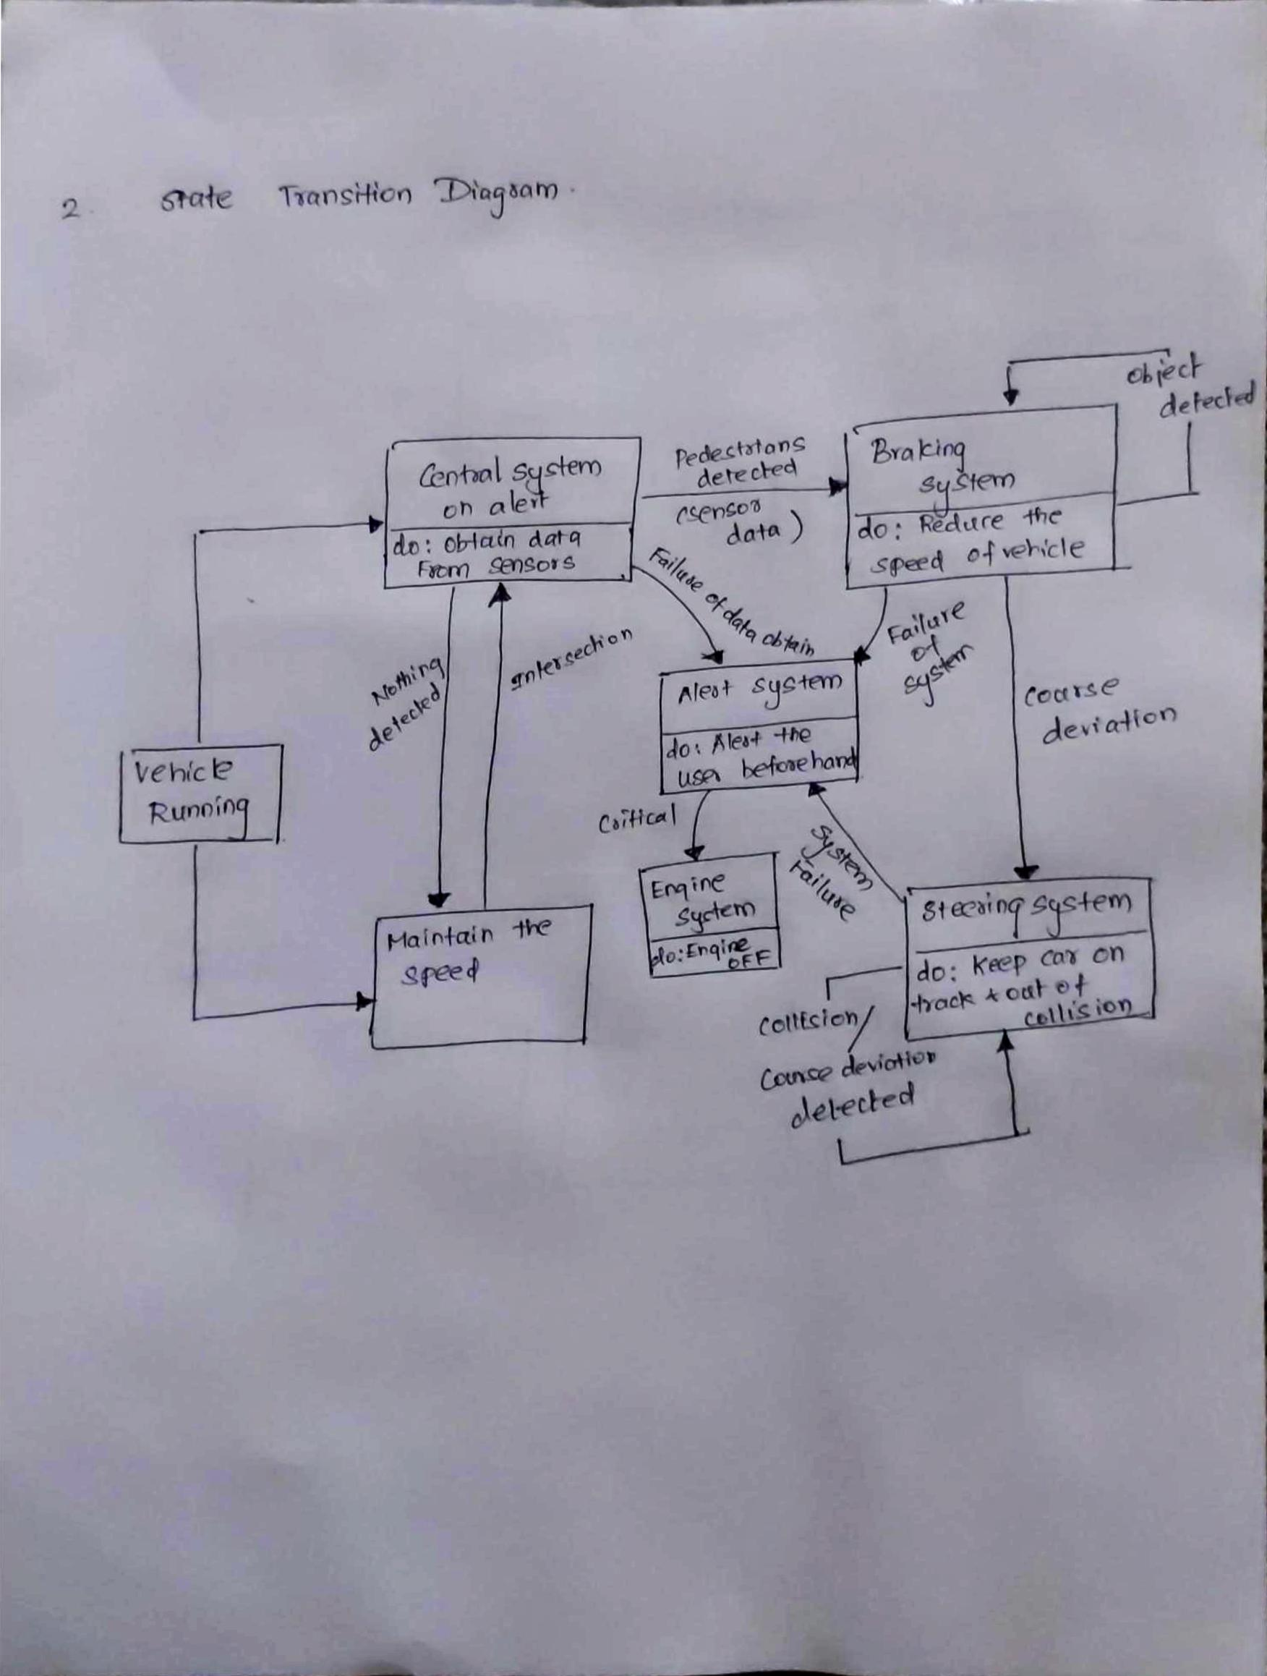

1. **Information dashboard**

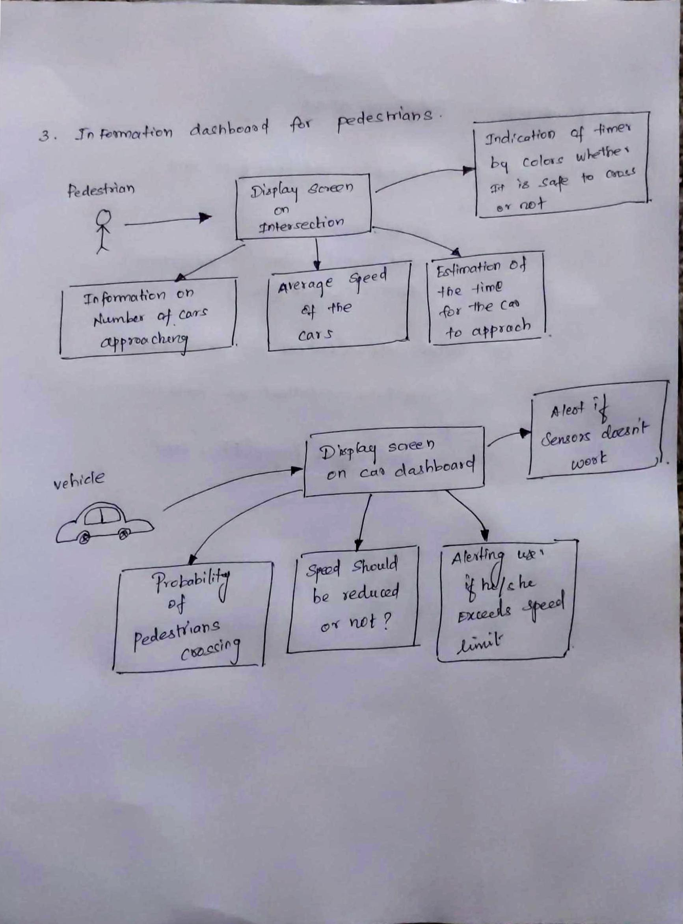

1. **Pseudo code**

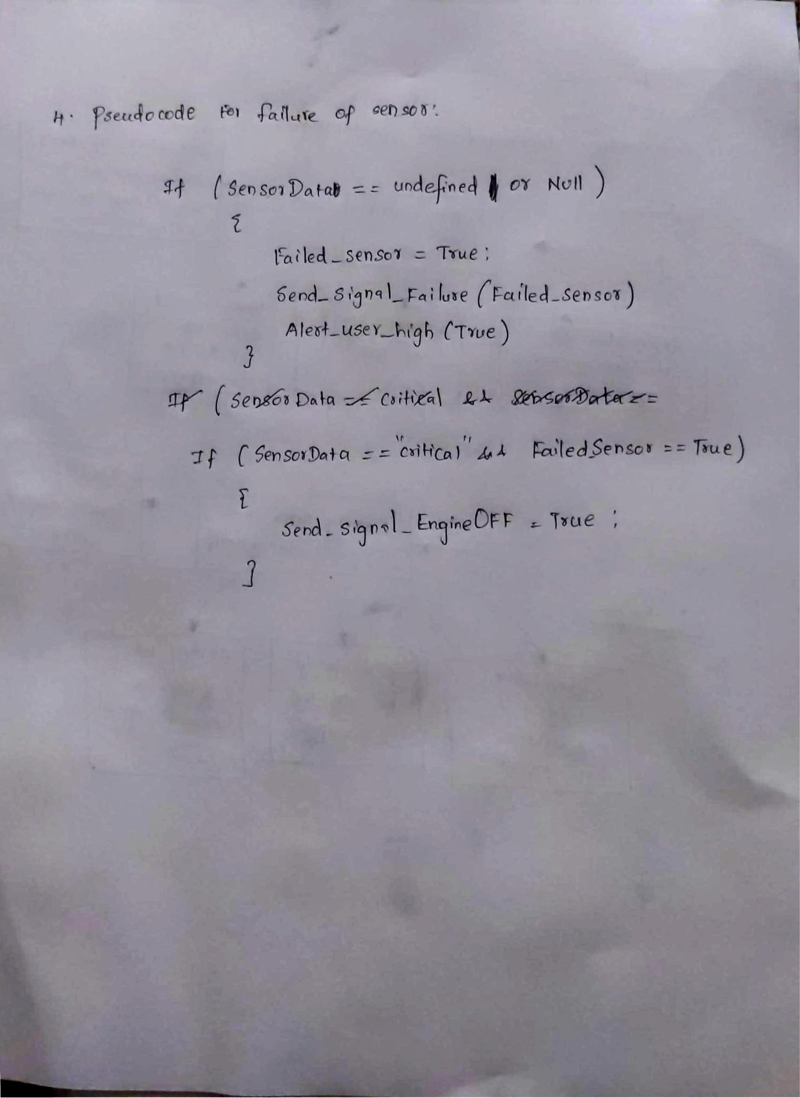

**5. Test plan how the system is efficient and safe**

System is efficient:

**Test case for Efficiency:**

**Input** (Initial): Data from sensors

**Execution**:

1. Analyze the data from sensors
2. Categorize them based on criticality.
3. Give the user the analyzed data and inform necessary steps to be taken to avoid collision.

**Output**: User is clear about the condition of the car

**Input**: Data from road side cameras and speed monitors

**Execution**:

1. Obtain the data from the cameras and monitors
2. Calculate the necessary details (average speed, time for the car to reach intersection).
3. Display the detail in the information dashboard for the pedestrians

**Output**: Pedestrians understand the situation and decide whether to proceed/retreat from crossing.

**Test case for Safety:**

**Input:** Failed sensor or controller system

**Execution:**

1. Find out which sensor failed to work or which controller (brake or steering).
2. Check whether the vehicle is in critical condition
3. Main system instructs to slow down and turn off the engine if necessary

**Output:** Vehicle should be kept safe despite the critical collision probability and reduce the damage by maximum amount.